**BANK LOAN REPORT QUERY DOCUMENT**

1. **BANK LOAN REPORT | SUMMARY**

**KPI’s:**

-- Total Loan Applications

SELECT COUNT(id) AS Total_Loan_Applications

FROM bank_loan_data



-- Month to Date Applications

SELECT COUNT(id) AS Month_to_Date_Applications

FROM bank_loan_data

WHERE MONTH(issue_date)=12 and YEAR(issue_date)=2021



--Previous Month to Date

SELECT COUNT(id) AS Previous_Month_to_Date_Applications

FROM bank_loan_data

WHERE MONTH(issue_date)=11 and YEAR(issue_date)=2021



--Total Funded Amount

SELECT SUM(loan_amount) AS Total_Amount_Funded

From bank_loan_data



--Month to Date Funded Amount

SELECT SUM(loan_amount) AS Total_Amount_Funded

From bank_loan_data

Where MONTH(issue_date)=12 and YEAR(issue_date) = 2021



-- Previous Month to Date Funded Amount

SELECT SUM(loan_amount) AS Total_Amount_Funded

From bank_loan_data

Where MONTH(issue_date)=11 and YEAR(issue_date) = 2021



--Total Amount Received

SELECT SUM(total_payment) as Total_Collected

FROM bank_loan_data



--Month To Date Amount Received

SELECT SUM(total_acc) AS Total_Collected

From bank_loan_data

Where MONTH(issue_date)=12 and YEAR(issue_date) = 2021



--Previous Month To Date Amount Received

SELECT SUM(total_acc) AS Total_Collected

From bank_loan_data

Where MONTH(issue_date)=11 and YEAR(issue_date) = 2021



--Average Interest Rate

SELECT ROUND(AVG(int_rate)*100,2) AS Average_Interest_Rate

FROM bank_loan_data



--Month to Date Average Interest Rate

SELECT ROUND(AVG(int_rate)*100,2) AS MTD_Average_Interest_Rate

FROM bank_loan_data

WHERE MONTH(issue_date)=12 and YEAR(issue_date)=2021



--Previous Month to Date Average Interest Rate

SELECT ROUND(AVG(int_rate)*100,2) AS MTD_Average_Interest_Rate

FROM bank_loan_data

WHERE MONTH(issue_date)=11 and YEAR(issue_date)=2021



--Average Debt to Income Ratio (DTI)

SELECT ROUND(AVG(dti)*100,2) AS DTI_AVG

FROM bank_loan_data



--Month to Date Debt to Income Ratio (DTI)

SELECT ROUND(AVG(dti)*100,2) AS MTD_DTI

FROM bank_loan_data

WHERE MONTH(issue_date)=12 and YEAR(issue_date)=2021



--Previous Month to Date Debt to Income Ratio (DTI)

SELECT ROUND(AVG(dti)*100,2) AS MTD_DTI

FROM bank_loan_data

WHERE MONTH(issue_date)=11 and YEAR(issue_date)=2021



--Good Loan Application Percentage

SELECT (COUNT(CASE WHEN loan_status = 'Fully Paid' or Loan_status ='Current' THEN id END)*100)

/ COUNT(id) AS Good_loan_Percentage

FROM bank_loan_data



--Good Loan Applicants

SELECT (COUNT(CASE WHEN loan_status = 'Fully Paid' or Loan_status ='Current' THEN id END)) AS Good_Loan_Applicants

FROM bank_loan_data

SELECT COUNT(id) AS Good_Loan_Applicants

From bank_loan_data

WHERE loan_status = 'Fully Paid' or loan_status = 'Current'



--Good Loan Funded Amount

SELECT SUM(loan_amount) AS Good_Loan_Funded

From bank_loan_data

WHERE loan_status = 'Fully Paid' or loan_status = 'Current'



--Good Loan Received Amount

SELECT SUM(total_payment) AS Good_Loan_Received

From bank_loan_data

WHERE loan_status = 'Fully Paid' or loan_status = 'Current'



--Bad Loan Application Percentage

SELECT (COUNT(CASE WHEN loan_status = 'Charged OFF' THEN id END)*100)

/ COUNT(id) as Bad_loan_Percentage

FROM bank_loan_data



--Bad Loan Applicants

SELECT (COUNT(CASE WHEN loan_status = 'Charged OFF'THEN id END)) AS Bad_Loan_Applicants

FROM bank_loan_data

SELECT COUNT(id) AS Bad_Loan_Applicants

From bank_loan_data

WHERE loan_status = 'Charged OFF'



--Bad Loan Funded Amount

SELECT SUM(loan_amount) AS Bad_Loan_Funded

From bank_loan_data

WHERE loan_status = 'Charged Off'



--Bad Loan Received Amount

SELECT SUM(total_payment) AS Bad_Loan_Received

From bank_loan_data

WHERE loan_status = 'Charged Off'



-- Loan Status Overview

SELECT loan_status, COUNT(id) AS Loan_Applications, SUM(loan_amount) AS Total_Funded_Amount, SUM(total_payment) AS Total_Amount_Received ,

ROUND(AVG(int_rate *100),2) AS Interest_Rate_Percentage, ROUND(AVG(dti *100),2) AS DTI_Percentage

FROM bank_loan_data

GROUP BY loan_status

--Adding the MTD overview

SELECT loan_status, SUM(total_payment) AS MTD_Total_Amount_Received, SUM(loan_amount) AS MTD_Total_Funded

FROM bank_loan_data

WHERE MONTH(issue_date) = 12

GROUP BY loan_status

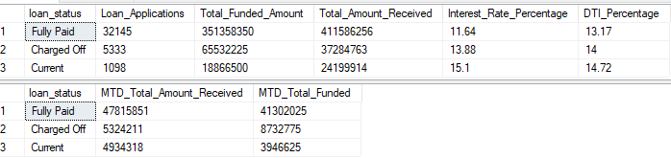

--MOM Trend Overview

Select

MONTH(issue_date) AS Month_Number,

DATENAME(MONTH, issue_date) AS Months, ---this date name is used to convert the date to month in the issue date comlumn

COUNT(id) AS Total_Loan_Applications,

SUM(loan_amount) AS Total_funded_amount,

SUM(total_payment) AS Total_Amount_Received

FROM bank_loan_data

GROUP BY MONTH(issue_date), DATENAME(MONTH, issue_date)

ORDER BY MONTH (issue_date)

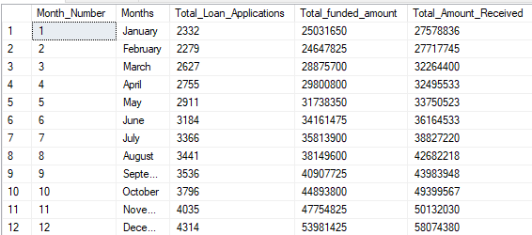

-- Loan Status Geo Overview

SELECT address_state AS State, COUNT(id) AS Loan_Applications, SUM(loan_amount) AS Total_Funded_Amount, SUM(total_payment) AS Total_Amount_Received

FROM bank_loan_data

GROUP BY address_state

ORDER BY SUM(loan_amount) DESC

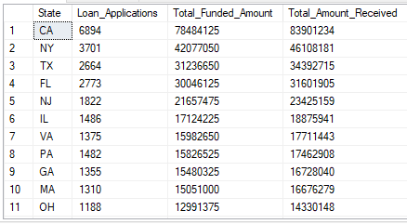

-- Loan Terms Overview

SELECT term AS Loan_Term, COUNT(id) AS Loan_Applications, SUM(loan_amount) AS Total_Funded_Amount, SUM(total_payment) AS Total_Amount_Received

FROM bank_loan_data

GROUP BY term

ORDER BY term DESC

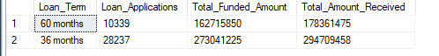

-- Employee Length Overview

SELECT emp_length AS EMP_Length, COUNT(id) AS Loan_Applications, SUM(loan_amount) AS Total_Funded_Amount, SUM(total_payment) AS Total_Amount_Received

FROM bank_loan_data

GROUP BY emp_length

ORDER BY emp_length

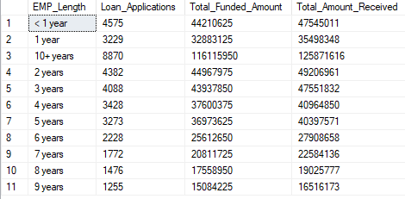

-- Purpose of Loan Overview

SELECT purpose AS Reasons, COUNT(id) AS Loan_Applications, SUM(loan_amount) AS Total_Funded_Amount, SUM(total_payment) AS Total_Amount_Received

FROM bank_loan_data

GROUP BY purpose

ORDER BY COUNT(id) DESC

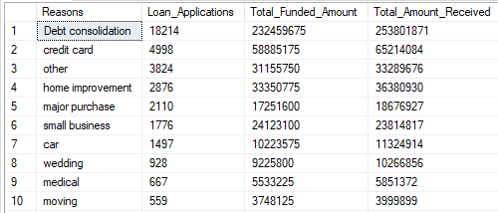

-- Home Ownership Overview

SELECT home_ownership AS Reasons, COUNT(id) AS Loan_Applications, SUM(loan_amount) AS Total_Funded_Amount, SUM(total_payment) AS Total_Amount_Received

FROM bank_loan_data

GROUP BY home_ownership

ORDER BY COUNT(id) DESC

